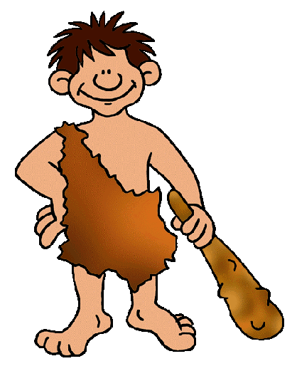
Name:____________________________________________________#________Date:____________________
Early Humans Foldable
Assessment
Due Date:______________
Directions: Create a display of information about the 5 different types of early humans. See specific instructions below. Samples will be provided in class. Use chapters 1 and 2 in your social studies book.

Front Cover: Label the front cover EARLY HUMANS. Be sure to include related artwork and keep it colorful and creative. See below.
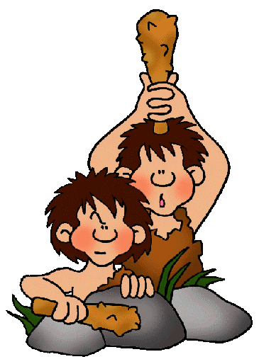
Early Humans
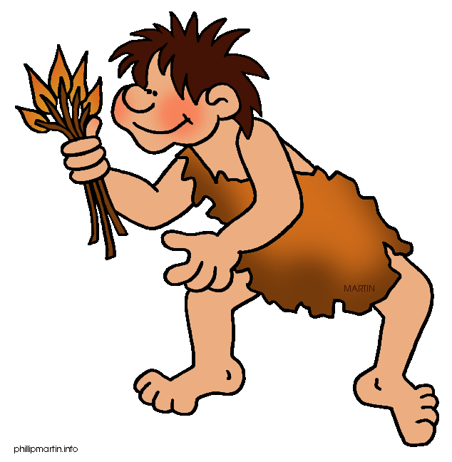

Inside Top: Title/label the 5 types of early humans across the top: Australopithecus, Homo Habilis, Homo Erectus, Neanderthal, and Cro-Magnon. Use your chart of information you collected with your group to include 6-8 bullet points of important information. See below.

Australopithecus | Homo Habilis | Homo Erectus | Neanderthal | Cro-Magnon

Inside Bottom: Illustrate each type of early human. Include a detailed caption. Illustrations should be colorful and reflect the early human you’re trying to represent. See below. Use the internet for more ideas.

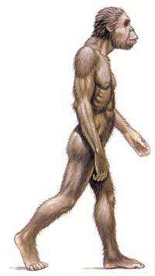 | 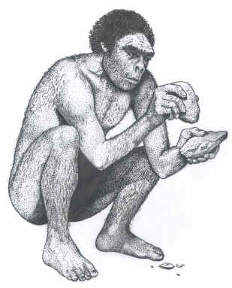 | 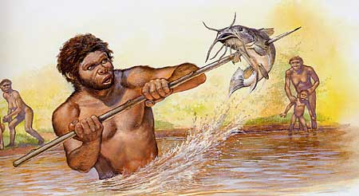 | 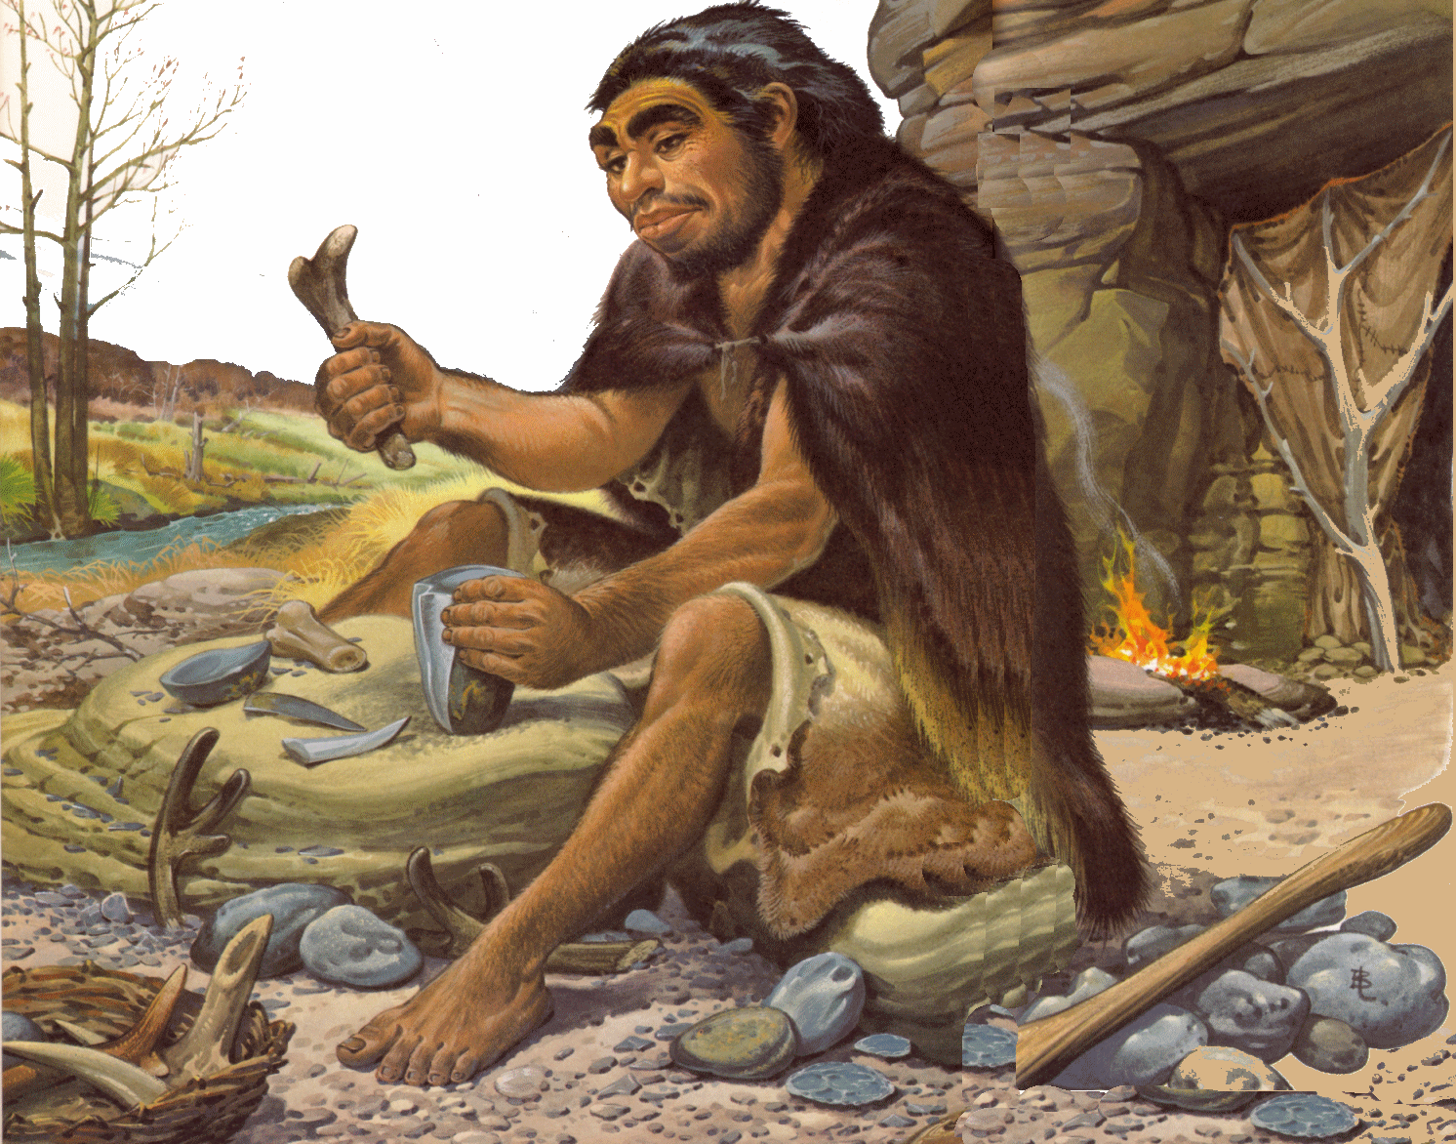 | 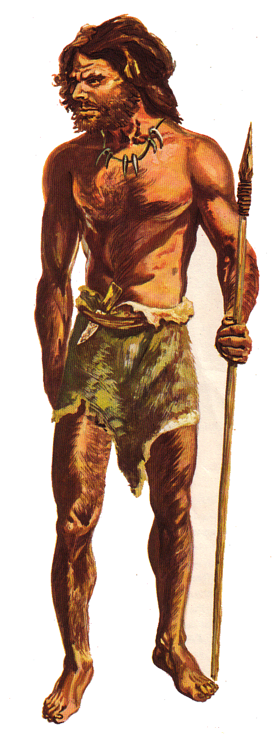
Write a caption | Write a caption | Write a caption | Write a caption | Write a caption

Early Humans Foldable
Assessment Rubric

_________________________________
Name

Requirement | Points Earned | Points Possible
Front Cover  Correctly Labeled  Colorful  Illustrations/Artwork |  | 20
Inside Top  Correctly Labeled  Accurate Information  Sufficient Information |  | 25
Inside Bottom  Detailed Captions  Thoughtful illustrations  Accuracy of illustrations & captions |  | 25
Neatness & Design  Neatness & Effort  Format & Layout  Colorful & Creative |  | 15
Language Conventions  Spelling  Grammar  Fluency  Capitalization  Punctuation |  | 15
Total |  | 100
Comments:

