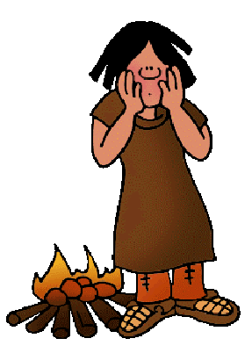

**Smelting:**

**Mixing tin and iron makes bronze which changes everything!**

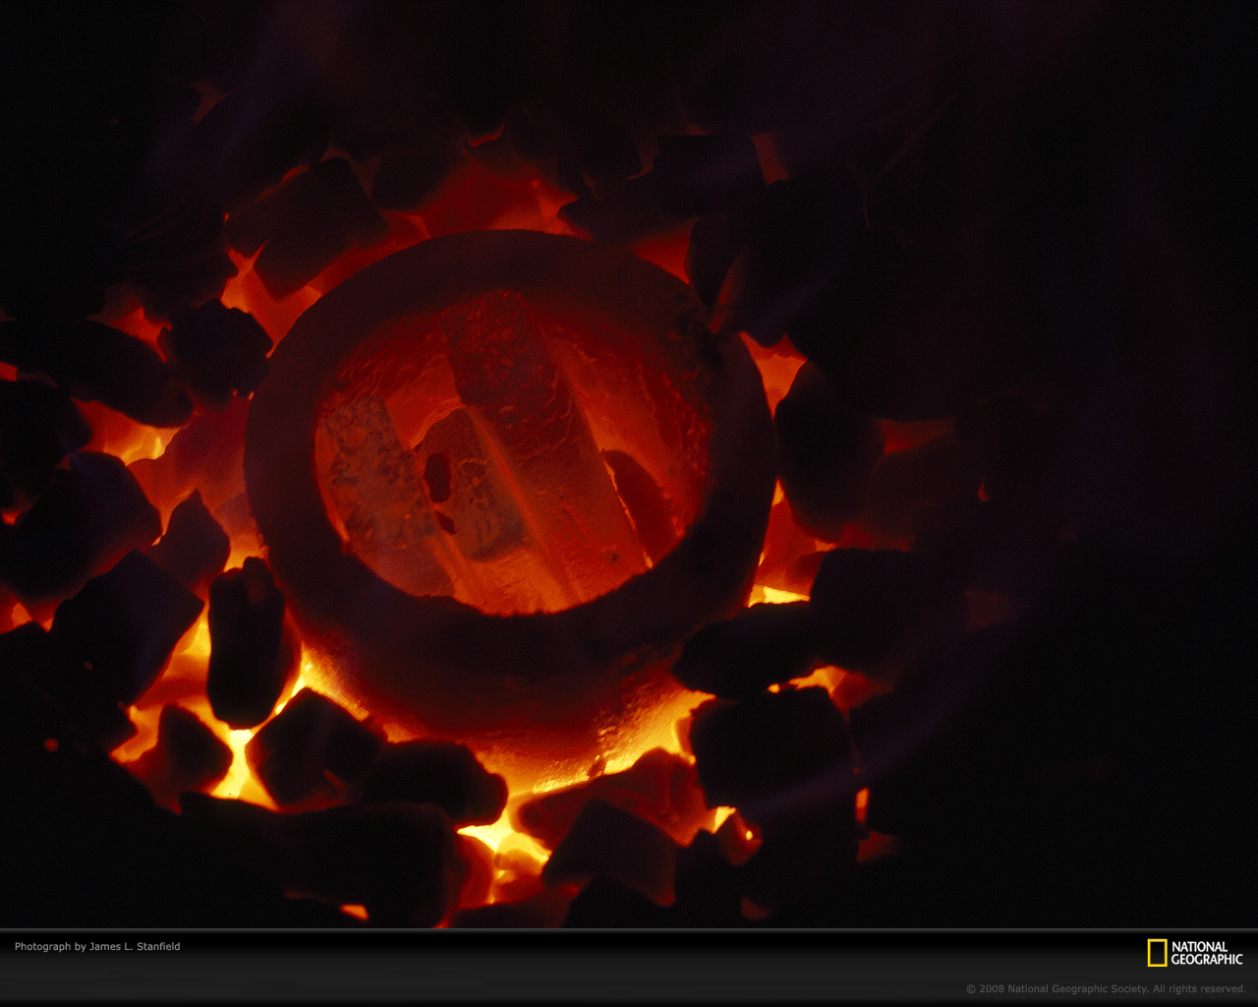

**Culture / Language**

**Gathering around a campfire people passed on information**

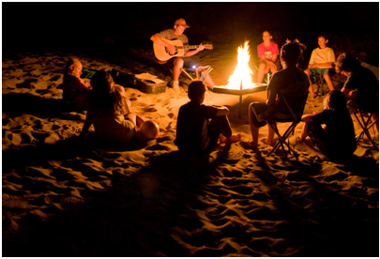

**Warmth:**

**Fire helped early humans survive colder climates!**



**Cooking**

**Meat over flame**

**(Nutrition increases brain size** 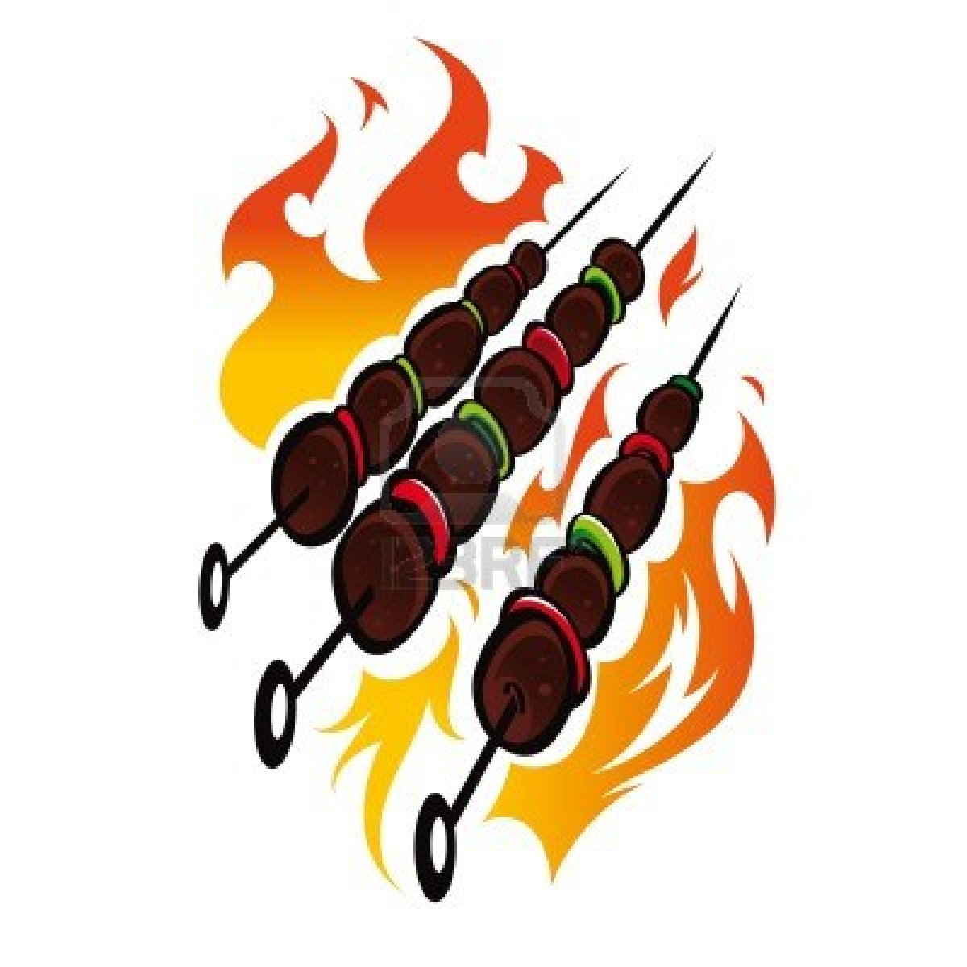

**Protection:**

**Fire was used to ward off predators!**

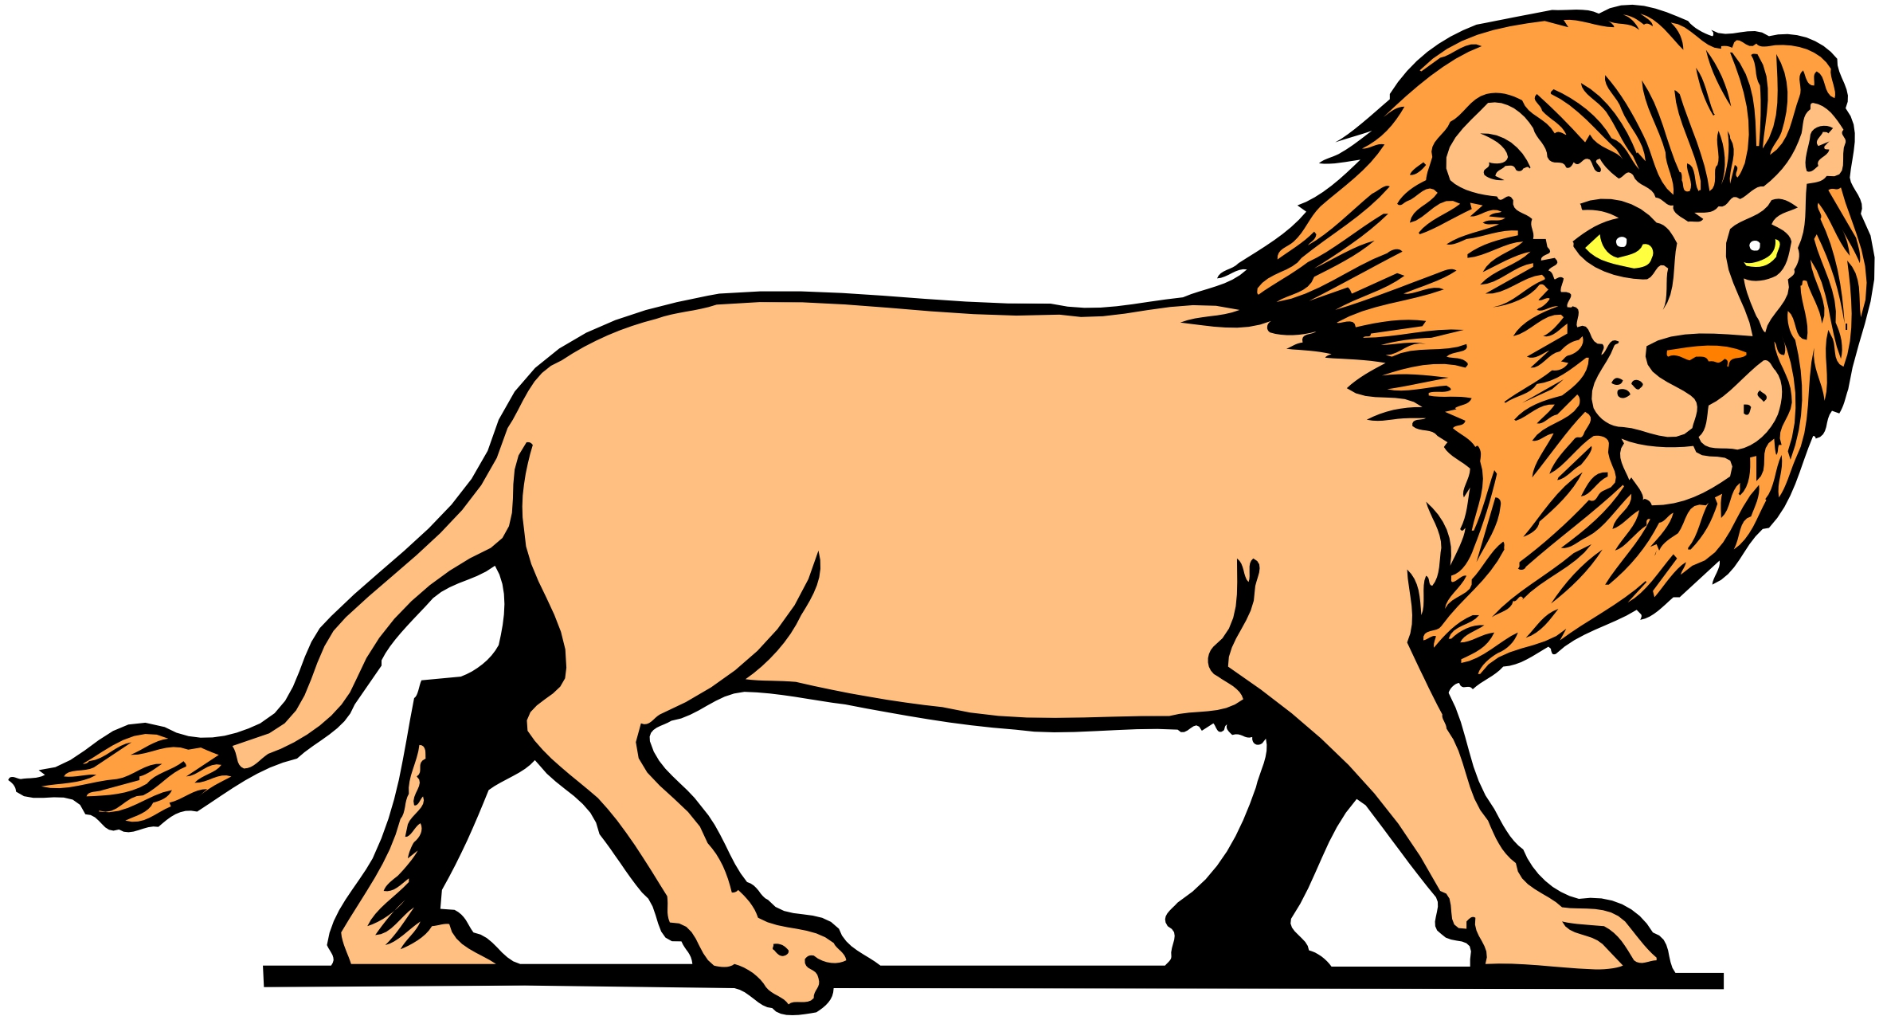

Cause and Effects: The Control of

Fire