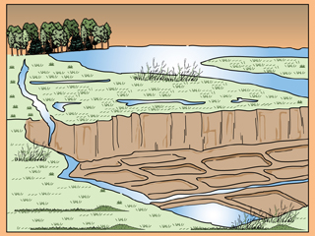
The River’s Bounty
Diagram of basin irrigation

Ancient Egyptians took advantage of the Nile's cyclical flooding and its rich sediments. They began sowing seeds in the mud after the flood waters receded. Eventually, in order to gain the greatest benefit from the Nile’s waters, the Egyptians developed irrigation systems that carried water from the river to plants in their fields. These systems enabled Egyptian farmers to plant crops beyond the river valley, and keep them watered all season.
One of the earliest irrigation methods Egyptians used was called basin irrigation. The flat fields along the river were divided by mounds of dirt into basins, depressions that could hold water. Some of the basins were as large as 50,000 acres (20,000 hectares). The basins would flood during the Akhet stage and remain flooded for up to six weeks, covering the field with giant puddles. The basins would drain when the river receded, leaving behind a thin layer of silt. During the Peret stage, the Egyptians would sow crops in the basins.
Later, farmers created irrigation canals. These canals allowed the farmers to grow crops further away from the river. Farmers used several tools to move water from the river or irrigation canals to their fields. One tool the Egyptians developed was a lever device called a shadoof. The shadoof made it easier for farmers to gather water and move it to their fields.
The chief crops grown along the Nile River Valley were wheat, barley, vegetables, and flax. Egyptians made bread and beverages from the wheat and barley, which were stored in large silos. They wove flax into linen.
Another important crop in ancient Egypt was a reed called papyrus. Papyrus was a plant that could be made into a paper-like writing material of the same name. Papyrus grew easily in marshes and was also used to make rope, matting, and sandals. Papyrus eventually became one of Egypt’s most important crops.
Egyptians also raised animals for food and to work the fields. Cattle, sheep, goats, pigs, ducks, and geese were common domestic animals. A particular breed of cattle was raised for meat, while another was used for milk. Egyptians also bred hunting dogs, as well as a type of fat-tailed sheep which they used for its meat and milk.
Question: How did the Nile River influence the growth of agriculture in ancient Egypt? Use THREE (3) examples from the text to support your answer. (RESTATE THE QUESTION)
__________________________________________________________________________________________________________________________________________________________________________________________________________________________________________________________________________________________________________________________________________________________________________________________________________________________________________________________________________________________________________________________________________________________________________________________________________________________________________________________________________________________________________________________________________________________________________________________________________________________________________

