5 Themes of Geography Study Guide
Part 1: Fill in the blank.
- The study of Earth is called _____________________________.
- Lines of latitude run __________ and ________.
- Lines of longitude run __________ and ________.
- The equator is located at ___________________.
- The prime meridian is located at ______________.
Part 2: Definitions in YOUR OWN WORDS with 2 Examples [Can be pictures].
Term | Buzzwords | Example
Location
Movement
Place
Region
Human Environment Interaction
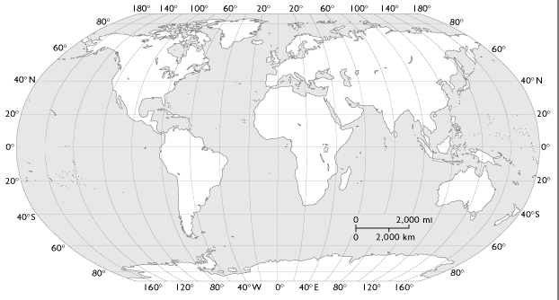
Part 3: Use the map to answer to find the following locations.

Part 2: Use the map to complete the following:
11. Highlight the Equator
12. Highlight the Prime Meridian
13-16. Label the 4 hemispheres

Part 4: Fill out Mr. Help with the correct theme that starts with each letter.
M=
R.=
H=
E=
L=
P=
Part 5: Use the pictures below to identify the Geography theme and give the definition.
